*Florida International University*

*School of Computing and Information Sciences*

Software Engineering Focus

Feature Document

User Story #**118**

**Team Member:**

Fernando Campo

**Product Owner(s)**:

Mohsen Taheri

**Mentor(s)**:

Vladan Lalovic

**Instructor**: Masoud Sadjadi

**User Story**

* As a user, when I open the Neat app on my phone, I want to see a short "loading screen" before I'm directed to the proper page.

Acceptance Criteria

* The Neat logo should be displayed in the center of the screen. Consider using a background color that complements the Neat logo.
* At the end of the loading screen, the user should be taken to the appropriate page. (For example, if this is the user's first time ever opening Neat, they should be taken to the page that asks if they are a new user so that they can register an account. If the user has a saved username and password, automatically attempt to log them in. And so on. Consider all possibilities.)
* It should take less than 3 seconds to show the Neat logo and execute the logic that determines which page to direct the user to.

**Use Case** #**118 – Create Loading Screen**

Details:

Actor: Student

Pre-conditions:

1. User has logged in once successfully and has not logged out.

Description:

1. Use case begins when student has entered their username and password and clicks Login.
2. App communicates with login endpoint and returns a token.
3. App saves login token to local storage.

Post-conditions:

1. Login token is saved in local storage.

Alternative Course of Action:

1. N/A

Exceptions:

N/A

Related Uses Case:

N/A

Decision Support:

Frequency: Low. Estimated average of one addition per application execution.

Criticality: High. Allows the Student to save login token for future server requests.

Risk: Low. Implementing this use case employs standard web-based technology

Constraints:

1. Usability:
   1. No training time  required.
2. Reliability:
   1. Mean time to Failure – 1% failures is acceptable.
   2. Availability – Always available.
3. Performance:
   1. The save token action should be saved within 5 seconds
4. Supportability:
   1. Feature must appear on mobile devices.

Modification History:

Owner: Fernando Campo.

Initiation date: 10/25/2016

Date last modified: 10/25/2016

**Sequence Diagram**

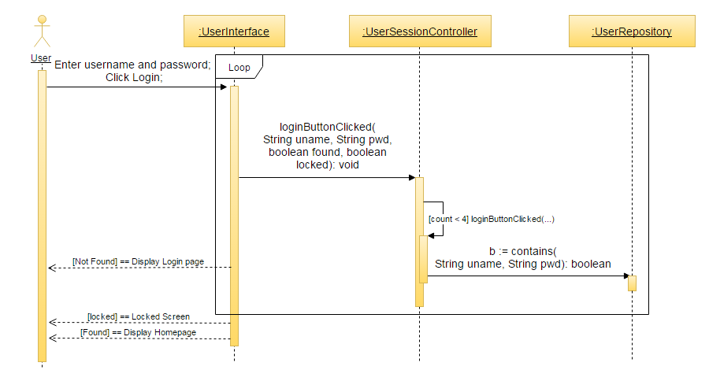

**Integration Test**

**Test Case 1 (Sunny Day)**

**ID: NEAT-SD-118-01**

**Purpose**

* Test if user is taken to the login screen

**Precondition**

* User has not logged into the app before

**Expected Result**

* User is taken to the login screen

**Actual Result**

* User is taken to the login screen

**Test Case 1 (Sunny Day)**

**ID: NEAT-SD-118-02**

**Purpose**

* Test if user is taken to the dashboard screen

**Precondition**

* User has logged into the app before

**Expected Result**

* User is taken to the dashboard screen

**Actual Result**

* User is taken to the dashboard screen

**Test Case 1 (Rainy Day)**

**ID: NEAT-RD-118-01**

**Purpose**

* Test if user is taken back to the login screen if username and password is wrong

**Precondition**

* User login is wrong
* User is at the login screen

**Expected Result**

* User is taken back to the login screen

**Actual Result**

* User is taken back to the login screen

**Visual User Guide**

